This is to certify that the project entitled “**GYM Website**” is successfully completed by **Chinmay Kesarkar** as per the syllabus and in partial fulfilment for the completion of BSc. degree in Computer Science of University of Mumbai, it is also to certify that this is the original work of the candidate done during the academic year 2022 – 2023.

Exam seat no:

Place:

Date:

**Signature of Guide Signature of Principal Signature of/Co-Ordinator**

**External Examiner**

**ABSTRACT**

Our Gym Management Software is a gym and health club membership management system. You can keep records on your members, their memberships, and have quick and easy communication between you and your members.

Our Gym Management Software is a complete gym and recreation facility system program which looks after all of your members, memberships and activities. It is designed for gyms, recreation centers, and health clubs.

Our Gym management Software provides lots of functions such data entry of customer, keeping records of all the things about customer's fees, plan, and physical fitness which help to provide good quality of services to customer from Gym managers.

In this proposed system also provide the total information about machinery and data of coaches is also stored in it. Services provided by Gym are also handled by this system.

**ACKNOWLEDGEMENT**

First of all, I would like praise to God, the Most Gracious and Most Merciful for giving the opportunity and strength in completing this project without extreme difficulties. I extend my sincere and heartfelt thanks to my esteemed guide, **Prof Abhijeet Salvi,** for providing me with the right guidance and advice at the crucial junctures and for showing me the right way. Also I would like to thanks the other faculty members at this occasion. I would like to thank my family and friends for the support and encouragement they have given me during the course of this work.

##### Chinmay Kesarkar

**TY BSc CS**

**DECLARATION**

I hereby declare that the project entitled, “**GYM Website**” done at Pillai College of Arts, Commerce & Science ( Autonomous) has not been in any case duplicated to submit to any other university for the award of any degree. To the best of my knowledge other than me, no one has submitted to any other university.

The project is done in partial fulfillment of the requirements for the award of degree of

###### BACHELOR OF SCIENCE (COMPUTER SCIENCE) to be submitted as final semester project as part

of our curriculum.

## TABLE OF CONTENTS

##### Chapter 1:Introduction

##### Objectives

* + **Purpose and Scope**
    - **Scope**

##### Organization of Report

##### Chapter 2: System Analysis

* + **Existing System**

##### Proposed System

* + **Requirement Analysis**

##### Hardware Requirements

* + **Software Requirements**

## Chapter 3 Requirement and Analysis

#### Problem Definition

* + **Requirements and Analysis**

#### Planning and Scheduling

#### Preliminary Product Description

* **Conceptual Models**

## Chapter 4 System Design

#### Basic Modules

**Chapter 5: Project implementation**

**Chapter 6: Conclusions**

**Chapter 7: References**

## Chapter 1

**Introduction**

* 1. **Objectives**

#### 1.2 Purpose, Scope and Applicability

* + 1. **Purpose**

#### Scope 1.2.3Applicability

**1.3 Organization of Report**

#### Objectives:

1. Gym management software is designed to simplify the running of a fitness club. From online gym scheduling and automated billing to administrative tasks, the software pulls all data into one place so that you can run your business more efficiently.
2. Without gym member management software, all tasks will need to be carried separately. For example, you may manage billing through one piece of software, keep track of administrative tasks somewhere else, and use a spreadsheet for financial forecasting. You may have member management information online or offline in the office. Either way, there is no one centralized spot where you can find all the information about your business. Gym management software is designed to streamline operations so that all of these tasks can be in one place.
3. In a world where technological advances occur so quickly, it can feel like a challenge to keep up. But gym and fitness clubs can maximize business potential through gym management software. This type of software has gone beyond just processing membership payments and additional admin tools. It can help you manage all facets of the business, retain and engage members, and, most importantly – grow.
   1. **Purpose and Scope**

The project is about to handle all the information of the gym regarding members. Also it manages resources which were managed and handled by manpower previously. The main purpose of the project is to integrate distinct sections of the shop into consistent manner so that complex functions can be handled smoothly. The project aims at the following matters

* + Buying gym membership.
  + To manage information of member.
  + Consistently update information of all the item.
  + Managing security by providing authorized email & password. Manages database efficiently.

##### Scope

It may help collecting perfect management in details. In a very short time, the collection will be obvious, simple and sensible. It will help a person to know the management of passed year perfectly and vividly. It also helps in current all works relative to Gym Website. It will be also reduced the cost of collecting the management & collection procedure will go on smoothly.

Our project aims at Business process automation, i.e. we have tried to computerize various processes of Gym Website.

## Chapter 2

### System Analysis

#### Existing Systems

* 1. **Proposed Systems**

#### Requirement Analysis

* 1. **Hardware Requirements**

#### Software Requirements

#### Existing Systems

**PhpMyAdmin**

PhpMyAdmin is a free and open-source MySQL management program application written in PHP and was first launched in 1998 under the GNU preferred Public License. It is cross-platform help for the essential working structures and helps management of more than one server. It supports most MySQL capabilities and has an intuitive net interface. It additionally has supports developing PDF graphics of database layout, importing information from CSV and SQL formats as well as exporting records to various codecs such as SQL, XML, PDF and, CSV.

**MySQL**

MySQL is a free source database system, and it enables the cost-effective delivery of reliable and a high-performance and scalable Web-based and embedded database applications. It is a relational database system (RDBMS). It is a high performing program and scalable to meet the demands of users and data. MySQL is written in C and C++, so it is compatible with most of the operating systems available around the world.

**XAMPP**

XAMPP is an integrated development surrounding, which incorporates Apache HTTP Server, MySQL Database, and PHP, Mercury, PERL or Python on a home Windows based computer. Apache is a free web server. MySQL is an open-source database. XAMPP is used in collaboration with, PHP, MySQL and, Windows 8 operating system

#### Proposed Systems

There are 3 kinds of proposed systems

* **Administrators**: Administrators are the ones who add or administer the categories for the products and administers the all website information’s. An administrator has full privilege of the website.
* **Customer**: People can receive various work requests from multiple and they can also reject or approve a request depending upon their interest.

#### Requirement Analysis

* It should be displayed along with to all the workflow users along with the name as per required.
* The application should provide access to authorized user sonly.
* The application should maintain a complete audit trail of all the user interactions with the system.
* The application should provide notification as Email to the users for all the activities requiring their attention.

#### Hardware Requirements

|  |  |  |  |
| --- | --- | --- | --- |
| **System’s** | **Operating System** | **Memory** | **Module’s** |
| **Windows 7**  **Windows 8.1** | Linux | X86 32-bit CPU (Intel / | Login |
| **Windows 10** | Mac OS X 10.11 or | AMD architecture) | Customer |
|  | Higher, 32-bit. | 2 GB RAM | Seller |
|  |  | 4 GB free disk space | Dashboard |

* 1. **Software Requirements**

|  |  |
| --- | --- |
| **Project Name:** | E-Commerce Website PHP MySQL |
| **Language’s Used:** | PHP |
| **PHP version:** | 5.6, 7.4 |
| **Database:** | MySQL |
| **Type:** | Website, Web Application |

## Chapter 3

### Requirement and Analysis

#### Problem Definition

* + **Requirements and Analysis**

#### Planning and Scheduling

#### Preliminary Product Description

* **Conceptual Models**

#### Problem Definition

* **Problem:** The pandemic has changed consumer behaviour with evolving trends on both demand and supply sides. Businesses are being forced to rethink their product offerings as well as delivery models.
* **Solution:** Leading Indian e-commerce brand Flipkart scaled up its supply chain along with strengthening safety and hygiene measures to meet the demand of the new consumer who is preferring to stay indoors.

#### Requirement Specification

* + - It should be displayed along with to all the workflow users along with the name of Village/Tehsil/District as required.
    - The application should be integrated with the DMIS.
    - The application should provide access to authorized users only
    - The application should maintain a complete audit trail of all the user interactions with the system
    - The application should provide notification via SMS and Email to the users for all the activities requiring their attention

#### Preliminary Product Description

* + - I have done a project on Online E-commerce Business(E-BUY)
    - The Online E-commerce Business (E-BUY) allows the administrator to view the data required.
    - This system provides simple and user-friendly Graphical User.

Interface for user simplicity.

**Conceptual Models**

ER Diagram

**Has**

**Asks**

**Visits**

**Subscription**

**Member**

**Account**

**Website**

**Selects**

**Has**

**SignUp**

Use case diagram

**Website**

**Member**

Activity Between Member And Website

Class Diagram

|  |
| --- |
| Subscription |
| Price:int  Package:varchar |
| Add()  Update()  Search() |

|  |
| --- |
| Member |
| Name: varchar  M_id: int  Contact: bigint  Gender: varchar  Address: varchar  Email: varchar |
| Add()  Update()  Delete()  Search() |

|  |
| --- |
| Website |
| Name: varchar  Details: varchar |
| Search()  Update() |

|  |
| --- |
| Account |
| Password: varchar  Email: varchar |
| Add()  Update()  Delete()  Search() |

|  |
| --- |
| SignUp |
| Name: varchar  Contact: bigint  Password: varchar  Email: varchar  Address: varchar |
| Add()  Update()  Delete() |

Object Diagram

|  |
| --- |
| **Subscription** |
| **Name: Pro Subscription**  **Price:Rs.12000** |

|  |
| --- |
| **Member** |
| **Name: Chinmay**  **M_id: 1**  **Contact: 123456789** |

|  |
| --- |
| **Website** |
| **Name:Fitness Studio**  **Details** **http://localhost/GYM/gym/index.php** |

Deployment Diagram

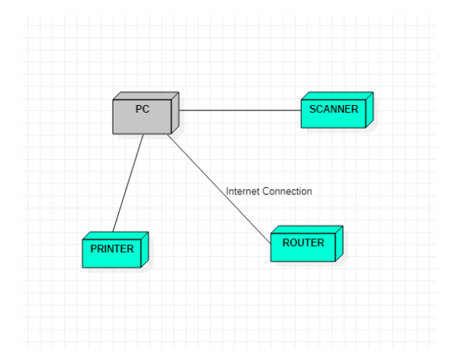

# 

# 

# Chapter 4

**System Design**

#### Basic Modules

* + **Data Design**

#### Schema Design

* + - **Data Integrity and Constraints**

#### Procedural Design

* + - **Logic Diagrams**

#### Data Structures

* + - **Algorithms Design**

#### User interface design

* + **Security Issues**

#### Test Cases Design

##### Basic Modules

* + - Login module: In this module, the member,admin can login to the system by entering login id and password. The system opens main account page after the login.
    - Member module: The member can register to the website by entering profile details. The member can take membership which are uploaded by administrator.
    - About Us Module: In this module, the user can see the information about this site and can view products related to the farm.
    - Service Module: In this module, the user can see what all services we can provide (with pictures and written contents).

**Output Pages**

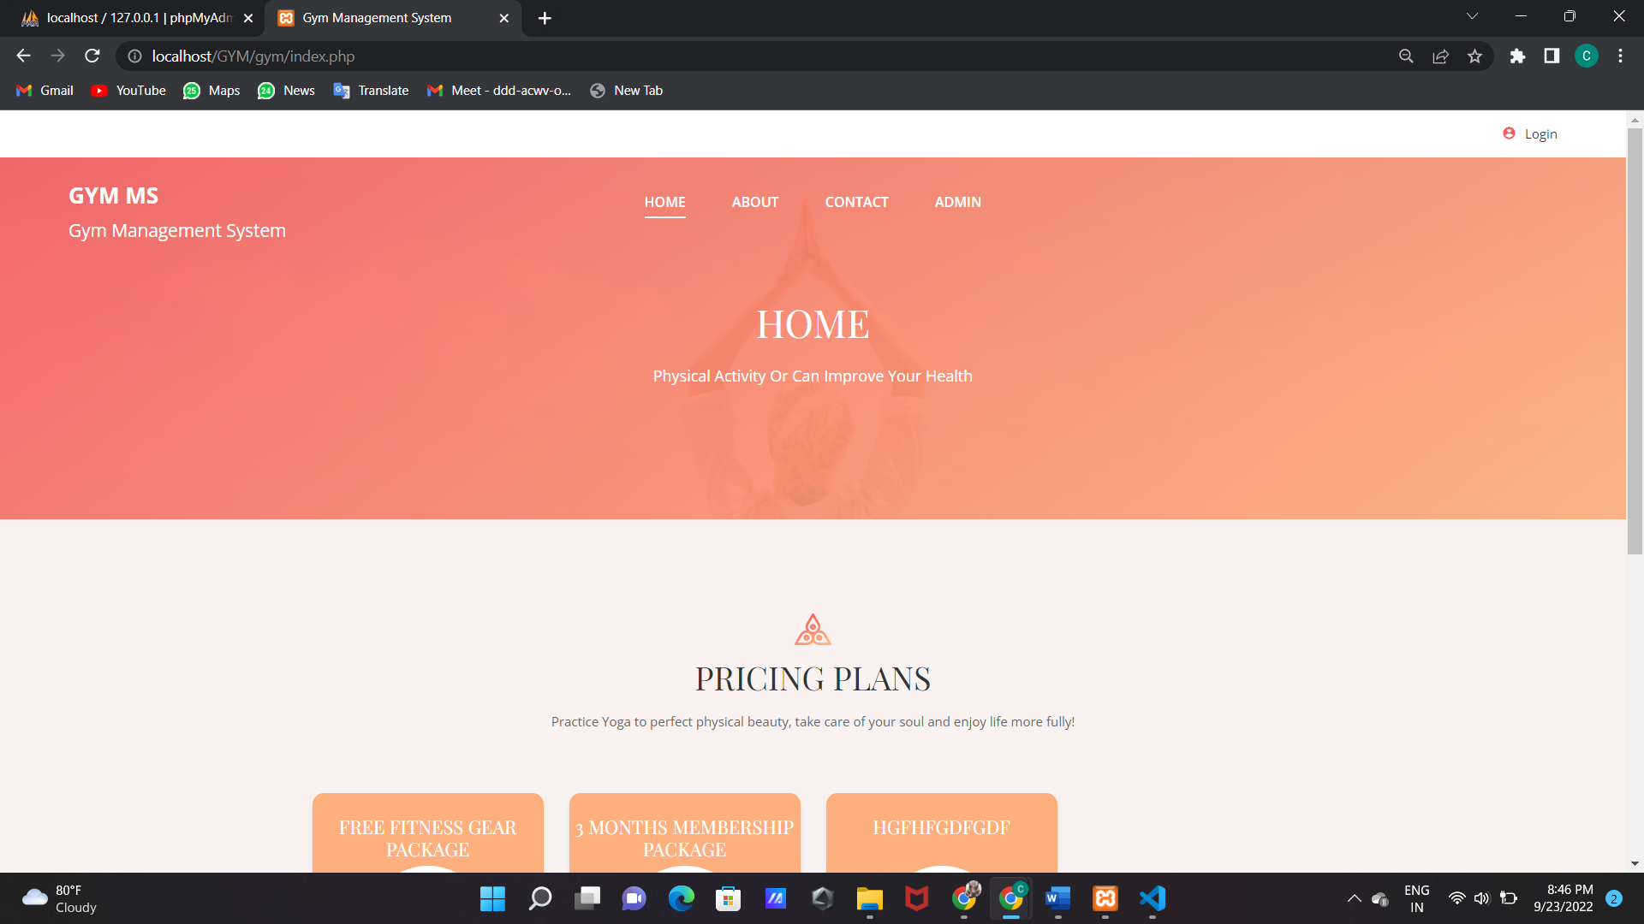

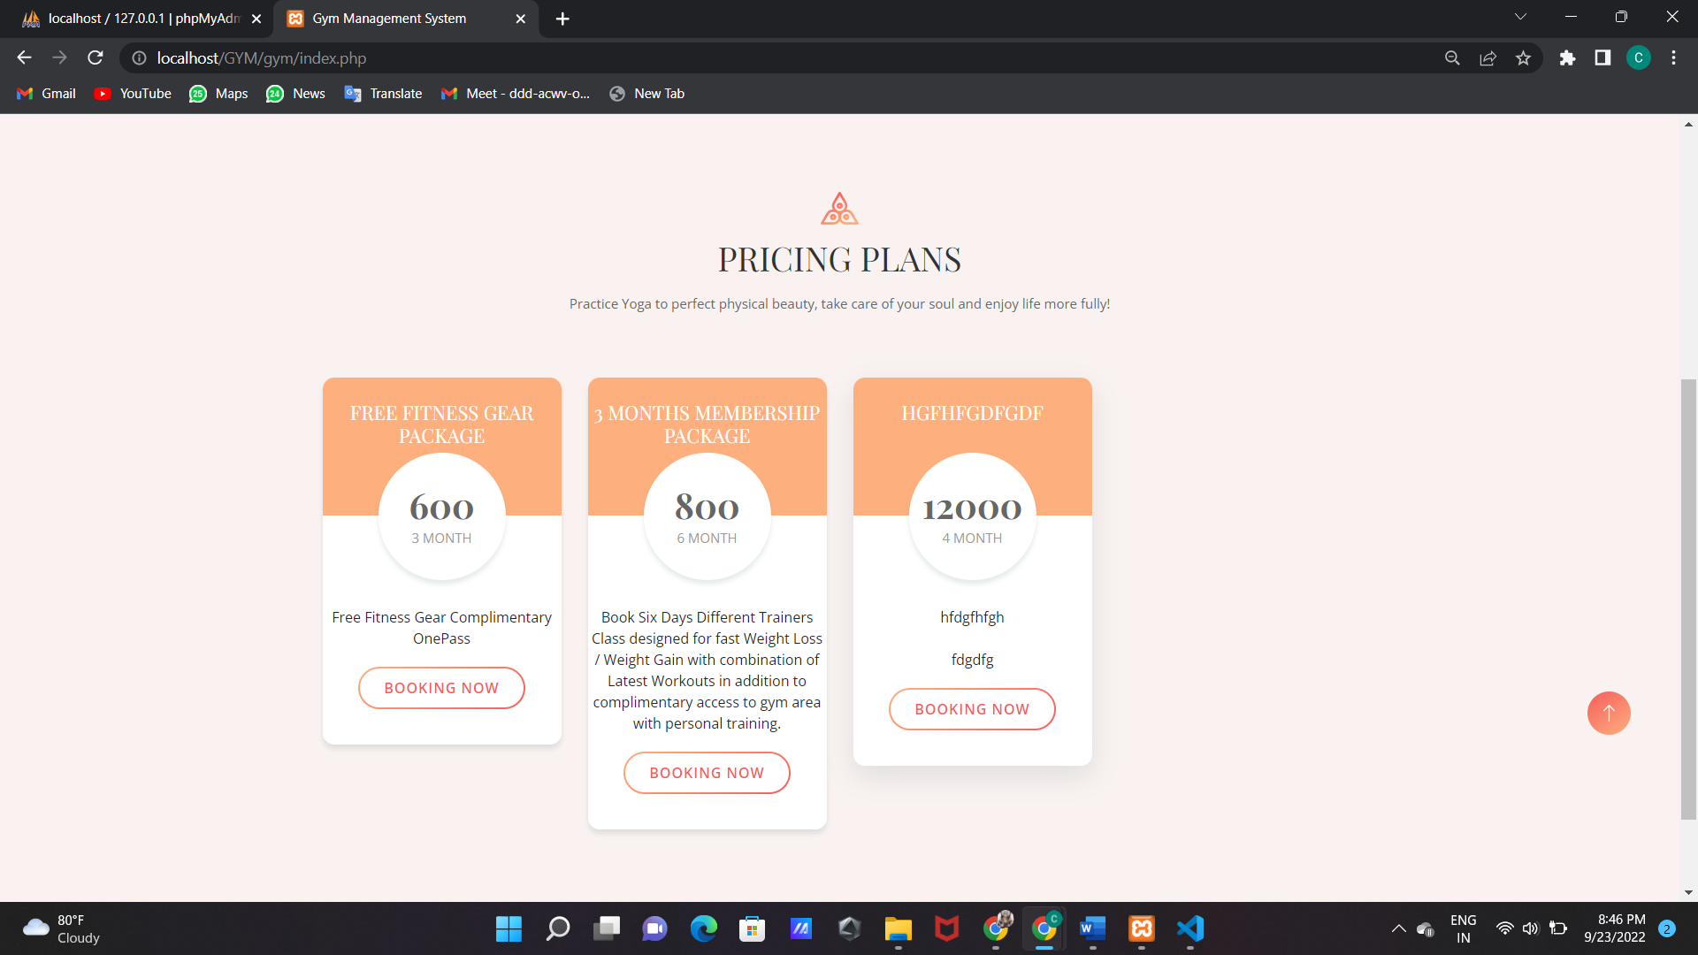

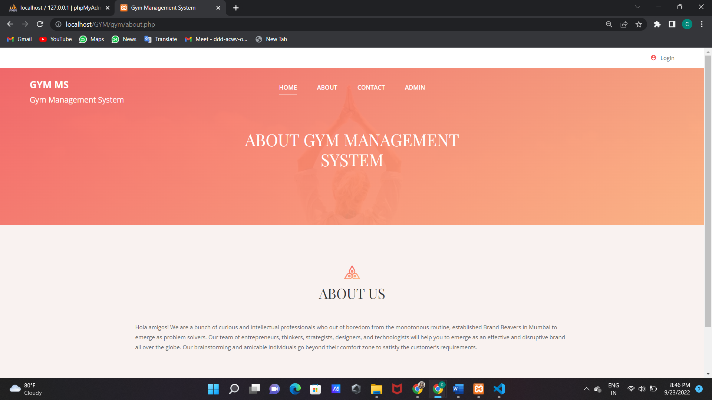 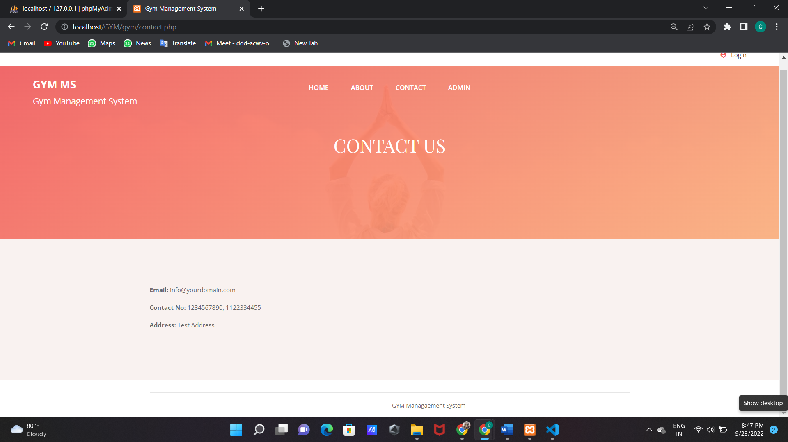

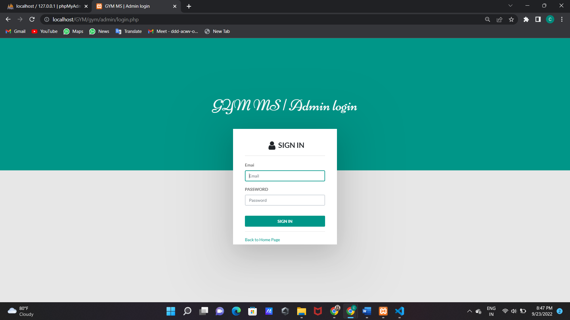

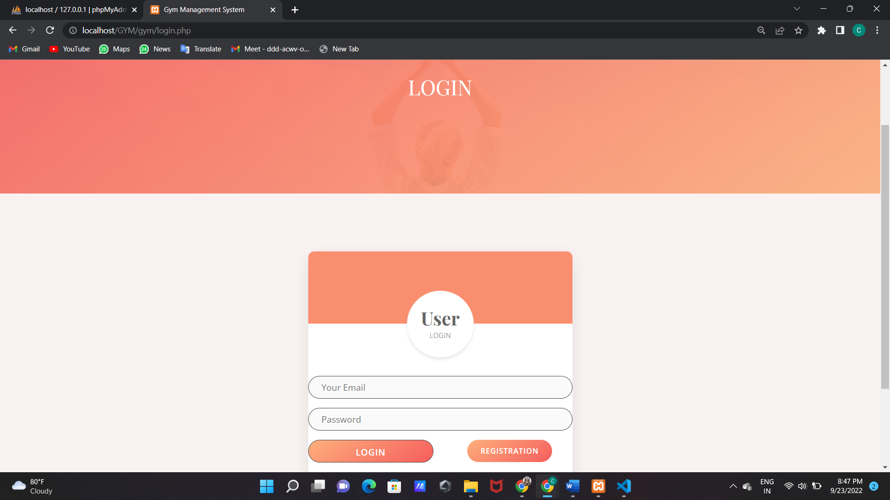

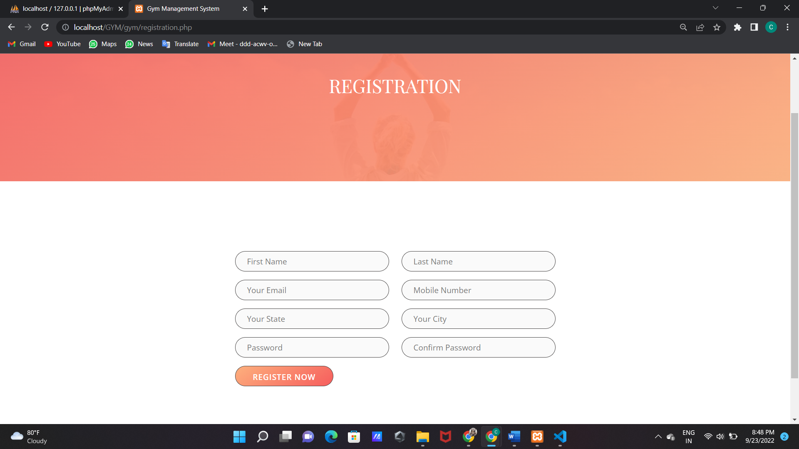

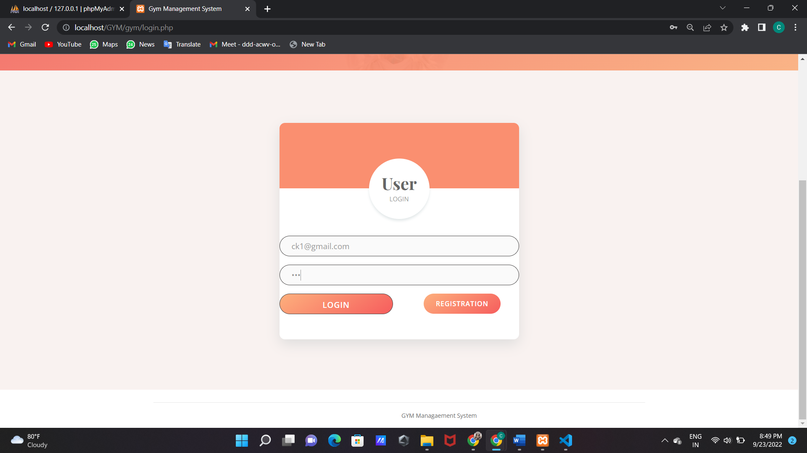

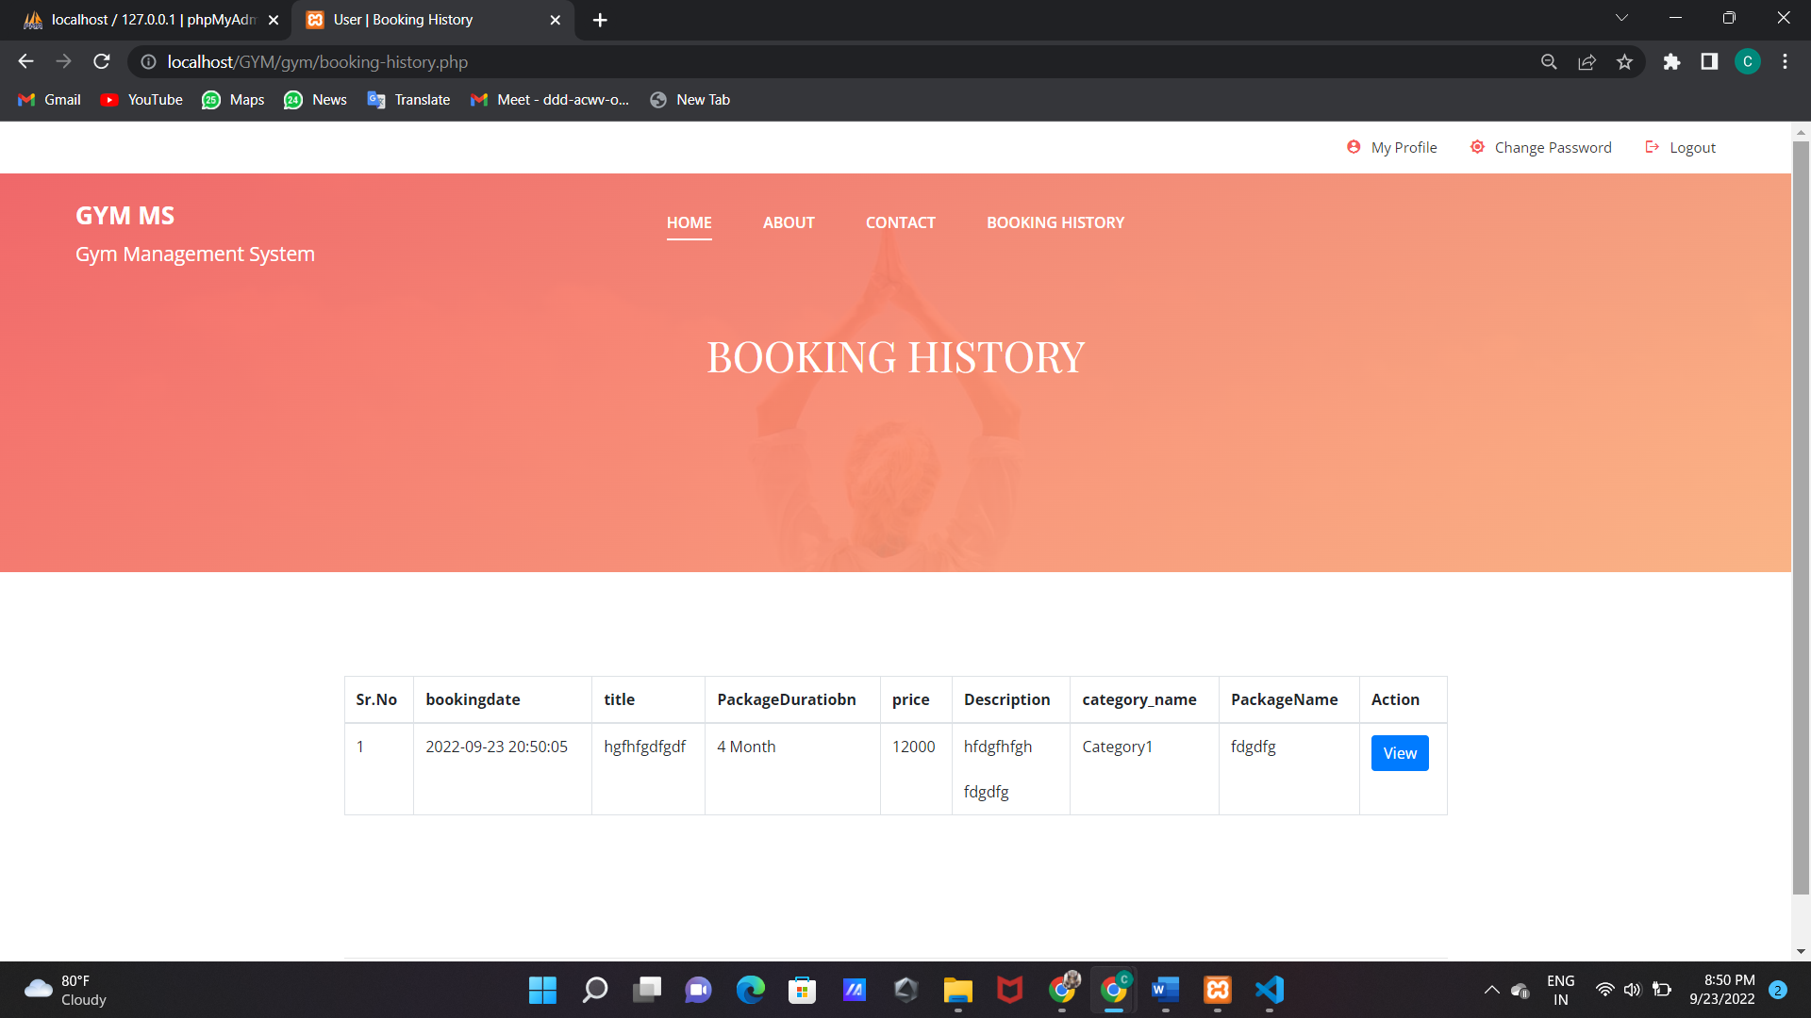

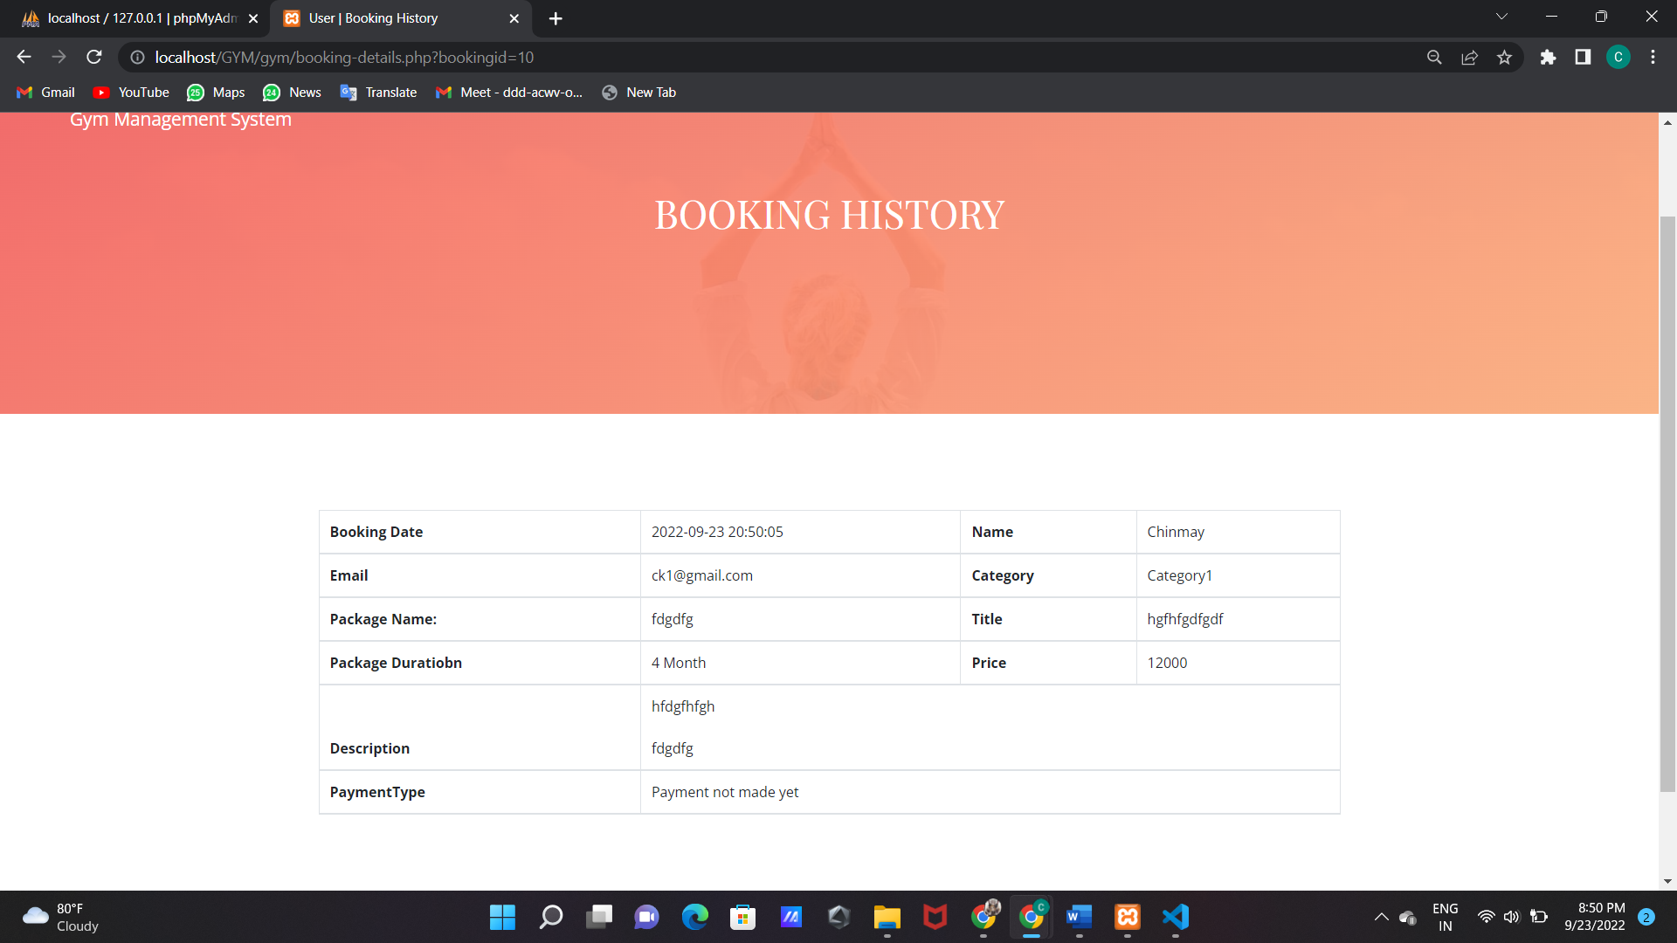

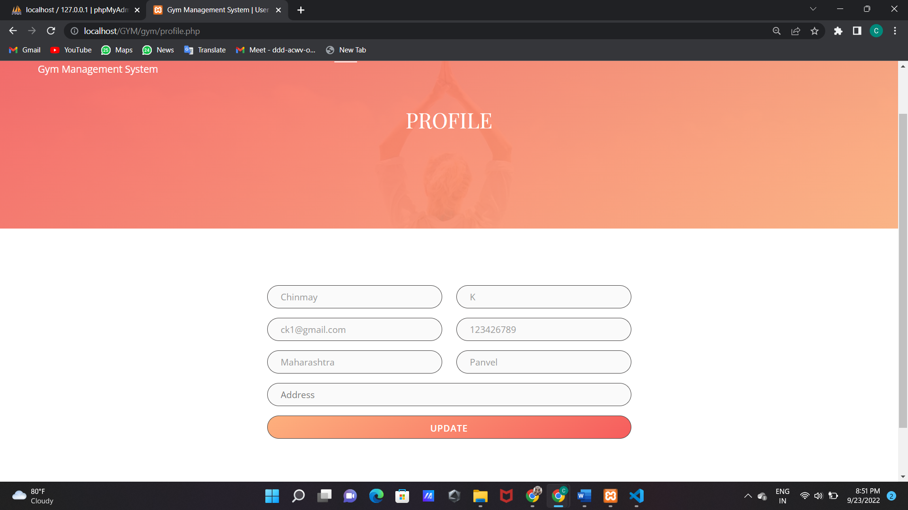

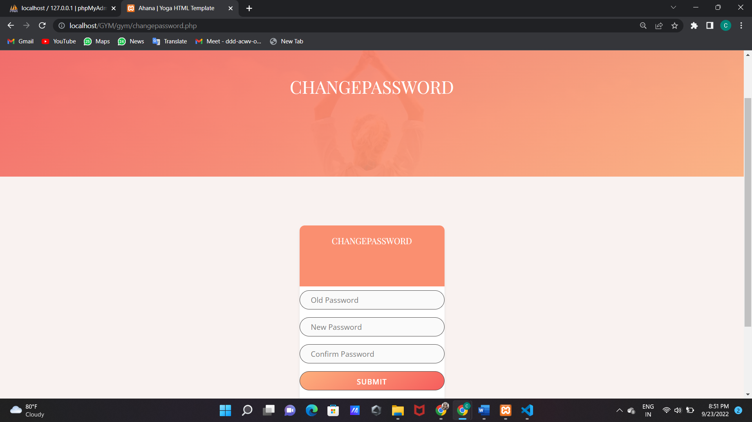

DATABASE

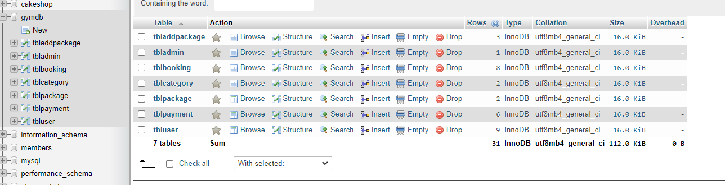

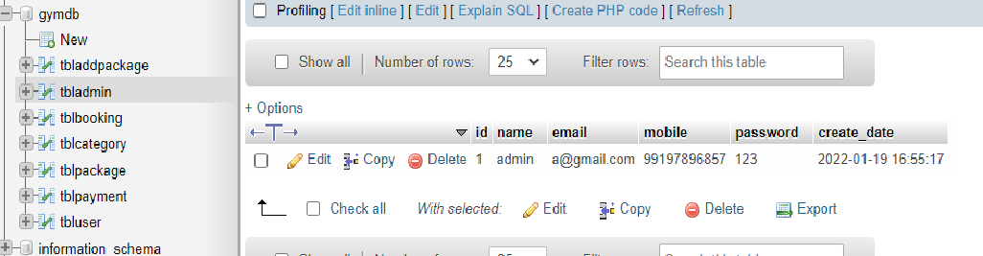

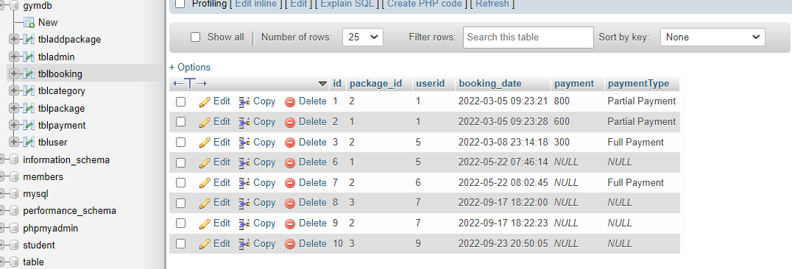

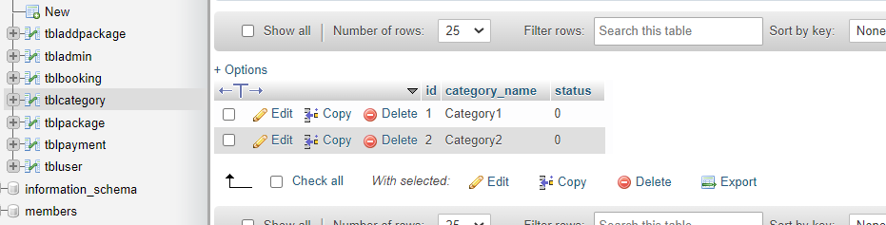

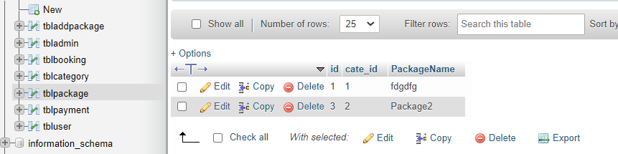

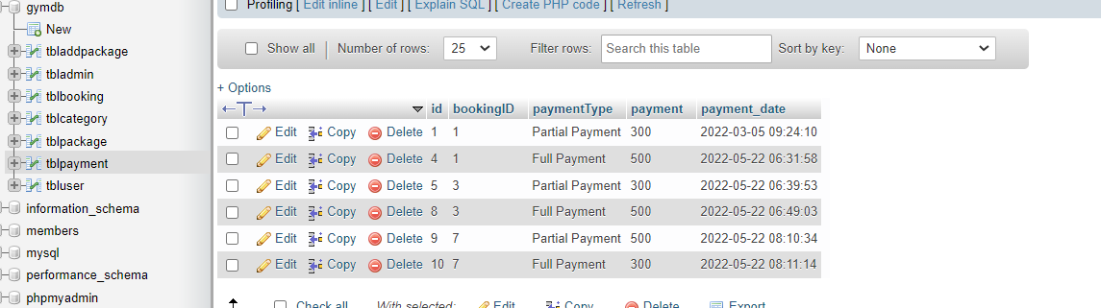

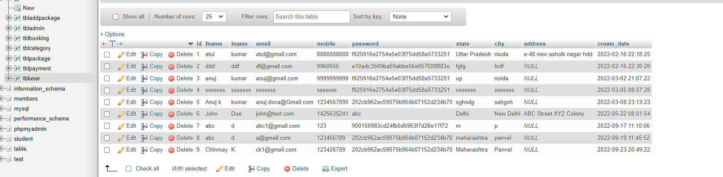

CODE  
  
  
About.php

<?php

session_start();

error_reporting(0);

include 'include/config.php';

$uid=$_SESSION['uid'];

if(isset($_POST['submit']))

{

$pid=$_POST['pid'];

$sql="INSERT INTO tblbooking (package_id,userid) Values(:pid,:uid)";

$query = $dbh -> prepare($sql);

$query->bindParam(':pid',$pid,PDO::PARAM_STR);

$query->bindParam(':uid',$uid,PDO::PARAM_STR);

$query -> execute();

echo "<script>alert('Package has been booked.');</script>";

echo "<script>window.location.href='booking-history.php'</script>";

}

?>

<!DOCTYPE html>

<html lang="zxx">

<head>

    <title>Gym Management System</title>

    <meta charset="UTF-8">

    <meta name="description" content="Ahana Yoga HTML Template">

    <meta name="keywords" content="yoga, html">

    <meta name="viewport" content="width=device-width, initial-scale=1.0">

    <!-- Stylesheets -->

    <link rel="stylesheet" href="css/bootstrap.min.css"/>

    <link rel="stylesheet" href="css/font-awesome.min.css"/>

    <link rel="stylesheet" href="css/owl.carousel.min.css"/>

    <link rel="stylesheet" href="css/nice-select.css"/>

    <link rel="stylesheet" href="css/magnific-popup.css"/>

    <link rel="stylesheet" href="css/slicknav.min.css"/>

    <link rel="stylesheet" href="css/animate.css"/>

    <!-- Main Stylesheets -->

    <link rel="stylesheet" href="css/style.css"/>

</head>

<body>

    <!-- Page Preloder -->

    <!-- Header Section -->

    <?php include 'include/header.php';?>

    <!-- Header Section end -->

    <!-- Page top Section -->

    <section class="page-top-section set-bg" data-setbg="img/page-top-bg.jpg">

        <div class="container">

            <div class="row">

                <div class="col-lg-7 m-auto text-white">

                    <h2>About GYM Management System</h2>

                </div>

            </div>

        </div>

    </section>

    <!-- Pricing Section -->

    <section class="pricing-section spad">

        <div class="container">

            <div class="section-title text-center">

                <img src="img/icons/logo-icon.png" alt="">

                <h2>About Us</h2>

            </div>

            <div class="row">

                <div class="col-lg-12 col-sm-6">

            <p>Hola amigos! We are a bunch of curious and intellectual professionals who out of boredom from the monotonous routine, established Brand Beavers in Mumbai to emerge as problem solvers. Our team of entrepreneurs, thinkers, strategists, designers, and technologists will help you to emerge as an effective and disruptive brand all over the globe. Our brainstorming and amicable individuals go beyond their comfort zone to satisfy the customer’s requirements.</p>

                </div>

            </div>

        </div>

    </section>

    <!-- Footer Section -->

    <?php include 'include/footer.php'; ?>

    <!-- Footer Section end -->

    <div class="back-to-top"><img src="img/icons/up-arrow.png" alt=""></div>

    <!-- Search model end -->

    <!--====== Javascripts & Jquery ======-->

    <script src="js/vendor/jquery-3.2.1.min.js"></script>

    <script src="js/bootstrap.min.js"></script>

    <script src="js/jquery.slicknav.min.js"></script>

    <script src="js/owl.carousel.min.js"></script>

    <script src="js/jquery.nice-select.min.js"></script>

    <script src="js/jquery-ui.min.js"></script>

    <script src="js/jquery.magnific-popup.min.js"></script>

    <script src="js/main.js"></script>

    </body>

</html>

Booking-details.php

<?php session_start();

error_reporting(0);

require_once('include/config.php');

if(strlen( $_SESSION["uid"])==0)

    {

header('location:login.php');

}

else{

$uid=$_SESSION['uid'];

?>

<!DOCTYPE html>

<html lang="zxx">

<head>

  <title>User | Booking History</title>

  <meta charset="UTF-8">

  <meta name="description" content="Ahana Yoga HTML Template">

  <meta name="keywords" content="yoga, html">

  <meta name="viewport" content="width=device-width, initial-scale=1.0">

  <!-- Stylesheets -->

  <link rel="stylesheet" href="css/bootstrap.min.css"/>

  <link rel="stylesheet" href="css/font-awesome.min.css"/>

  <link rel="stylesheet" href="css/owl.carousel.min.css"/>

  <link rel="stylesheet" href="css/nice-select.css"/>

  <link rel="stylesheet" href="css/slicknav.min.css"/>

  <!-- Main Stylesheets -->

  <link rel="stylesheet" href="css/style.css"/>

</head>

<body>

  <!-- Page Preloder -->

  <!-- Header Section -->

  <?php include 'include/header.php';?>

  <!-- Header Section end -->

  <!-- Page top Section -->

  <section class="page-top-section set-bg" data-setbg="img/page-top-bg.jpg">

    <div class="container">

      <div class="row">

        <div class="col-lg-7 m-auto text-white">

          <h2>Booking History</h2>

        </div>

      </div>

    </div>

  </section>

  <!-- Page top Section end -->

  <!-- Contact Section -->

  <section class="contact-page-section spad overflow-hidden">

    <div class="container">

      <div class="row">

        <div class="col-lg-12">

             <table class="table table-hover table-bordered">

                <thead>

                   <?php $bookindid=$_GET['bookingid'];

                  $sql="SELECT t1.id as bookingid,t3.fname as Name, t3.email as email,t1.booking_date as bookingdate,t2.titlename as title,t2.PackageDuratiobn as PackageDuratiobn,

t2.Price as Price,t2.Description as Description,t4.category_name as category_name,t5.PackageName as PackageName,payment,paymentType FROM tblbooking as t1

 join tbladdpackage as t2

on t1.package_id =t2.id

join tbluser as t3

on t1.userid=t3.id

join tblcategory as t4

on t2.category=t4.id

join tblpackage as t5

on t2.PackageType=t5.id

 where t1.id=:bookindid";

                  $query= $dbh->prepare($sql);

                  $query->bindParam(':bookindid',$bookindid, PDO::PARAM_STR);

                  $query-> execute();

                  $results = $query -> fetchAll(PDO::FETCH_OBJ);

                  $cnt=1;

                  if($query -> rowCount() > 0)

                  {

                  foreach($results as $result)

                  {

                  ?>

                  <tr>

                   <th>Booking Date</th>

                   <td><?php echo $result->bookingdate; ?></td>

                    <th>Name</th>

                    <td><?php echo $result->Name; ?></td>

                  </tr>

                  <tr>

                   <th>Email</th>

                   <td><?php echo $result->email; ?></td>

                    <th>Category</th>

                    <td><?php echo $result->category_name; ?></td>

                  </tr>

                  <tr>

                   <th>Package Name:</th>

                   <td><?php echo $result->PackageName; ?></td>

                    <th>Title</th>

                    <td><?php echo $result->title; ?></td>

                  </tr>

                  <tr>

                   <th>Package Duratiobn</th>

                   <td><?php echo $result->PackageDuratiobn; ?></td>

                    <th>Price</th>

                    <td><?php echo $result->Price; ?></td>

                    <?php $pricess=$result->Price; ?>

                  </tr>

                  <tr>

                   <th>Description</th>

                   <td colspan="3"><?php echo $result->Description; ?></td>

                  </tr>

                  <tr>

                   <th>PaymentType</th>

                   <td colspan="3"><?php  $ptype=$result->paymentType;

if($ptype==''):

  echo "Payment not made yet";

else:

  echo $ptype;

endif;

                 ?></td>

                  </tr>

                  <?php  $cnt=$cnt+1; } } ?>

                </thead>

              </table>

            <?php   $sql="SELECT * from tblpayment

 where bookingID=:bookindid";

                  $query= $dbh->prepare($sql);

                  $query->bindParam(':bookindid',$bookindid, PDO::PARAM_STR);

                  $query-> execute();

                  $results = $query -> fetchAll(PDO::FETCH_OBJ);

                  $cnt=1;

                  if($query -> rowCount() > 0)

                  { ?>

                       <table class="table table-hover table-bordered">

                        <tr>

                          <th colspan="3" style="text-align:center;font-size:20px;">Payment History</th>

                        </tr>

                        <tr>

                          <th>Payment Type</th>

                          <th>Amount Paid</th>

                          <th>Payment Date</th>

                        </tr>

 <?php foreach($results as $result)

                  { ?>

<tr>

  <td><?php echo $result->paymentType; ?></td>

  <td><?php echo $tpayment=$result->payment; ?></td>

  <td><?php echo $result->payment_date; ?></td>

</tr>

<?php

$gpayment+=$tpayment;

}  ?>

<tr>

  <th>Total</th>

  <th><?php echo $gpayment;?></th>

</tr>

                       </table>

                     <?php } ?>

        </div>

      </div>

    </div>

  </section>

  <!-- Trainers Section end -->

  <!-- Footer Section -->

<?php include 'include/footer.php'; ?>

  <!-- Footer Section end -->

  <div class="back-to-top"><img src="img/icons/up-arrow.png" alt=""></div>

  <!--====== Javascripts & Jquery ======-->

  <script src="js/vendor/jquery-3.2.1.min.js"></script>

  <script src="js/bootstrap.min.js"></script>

  <script src="js/jquery.slicknav.min.js"></script>

  <script src="js/owl.carousel.min.js"></script>

  <script src="js/jquery.nice-select.min.js"></script>

  <script src="js/jquery-ui.min.js"></script>

  <script src="js/jquery.magnific-popup.min.js"></script>

  <script src="js/main.js"></script>

  </body>

</html>

 <style>

.errorWrap {

    padding: 10px;

    margin: 0 0 20px 0;

    background: #dd3d36;

    color:#fff;

    -webkit-box-shadow: 0 1px 1px 0 rgba(0,0,0,.1);

    box-shadow: 0 1px 1px 0 rgba(0,0,0,.1);

}

.succWrap{

    padding: 10px;

    margin: 0 0 20px 0;

    background: #5cb85c;

    color:#fff;

    -webkit-box-shadow: 0 1px 1px 0 rgba(0,0,0,.1);

    box-shadow: 0 1px 1px 0 rgba(0,0,0,.1);

}

        </style>

        <?php } ?>

Booking-history.php

<?php session_start();

error_reporting(0);

require_once('include/config.php');

if(strlen( $_SESSION["uid"])==0)

    {

header('location:login.php');

}

else{

$uid=$_SESSION['uid'];

?>

<!DOCTYPE html>

<html lang="zxx">

<head>

  <title>User | Booking History</title>

  <meta charset="UTF-8">

  <meta name="description" content="Ahana Yoga HTML Template">

  <meta name="keywords" content="yoga, html">

  <meta name="viewport" content="width=device-width, initial-scale=1.0">

  <!-- Stylesheets -->

  <link rel="stylesheet" href="css/bootstrap.min.css"/>

  <link rel="stylesheet" href="css/font-awesome.min.css"/>

  <link rel="stylesheet" href="css/owl.carousel.min.css"/>

  <link rel="stylesheet" href="css/nice-select.css"/>

  <link rel="stylesheet" href="css/slicknav.min.css"/>

  <!-- Main Stylesheets -->

  <link rel="stylesheet" href="css/style.css"/>

</head>

<body>

  <!-- Page Preloder -->

  <!-- Header Section -->

  <?php include 'include/header.php';?>

  <!-- Header Section end -->

  <!-- Page top Section -->

  <section class="page-top-section set-bg" data-setbg="img/page-top-bg.jpg">

    <div class="container">

      <div class="row">

        <div class="col-lg-7 m-auto text-white">

          <h2>Booking History</h2>

        </div>

      </div>

    </div>

  </section>

  <!-- Page top Section end -->

  <!-- Contact Section -->

  <section class="contact-page-section spad overflow-hidden">

    <div class="container">

      <div class="row">

        <div class="col-lg-12">

          <table class="table table-bordered">

    <thead>

      <tr>

        <th>Sr.No</th>

        <th hidden>bookingid</th>

        <th hidden>Name</th>

        <th hidden>email</th>

        <th>bookingdate</th>

        <th>title</th>

        <th>PackageDuratiobn</th>

        <th>price</th>

        <th>Description</th>

        <th>category_name</th>

        <th>PackageName</th>

        <th>Action</th>

      </tr>

    </thead>

          <?php

          $uid=$_SESSION['uid'];

                  /*$sql="select id, product_id, userid, product_title, packages, category, PackageDuratiobn, price, descripation, booking_date from tblbooking where userid=:uid";*/

                  $sql="SELECT t1.id as bookingid,t3.fname as Name, t3.email as email,t1.booking_date as bookingdate,t2.titlename as title,t2.PackageDuratiobn as PackageDuratiobn,

t2.Price as Price,t2.Description as Description,t4.category_name as category_name,t5.PackageName as PackageName FROM tblbooking as t1

 join tbladdpackage as t2

on t1.package_id =t2.id

join tbluser as t3

on t1.userid=t3.id

join tblcategory as t4

on t2.category=t4.id

join tblpackage as t5

on t2.PackageType=t5.id

where t1.userid=:uid";

                  $query= $dbh->prepare($sql);

                  $query->bindParam(':uid',$uid, PDO::PARAM_STR);

                  $query-> execute();

                  $results = $query -> fetchAll(PDO::FETCH_OBJ);

                  $cnt=1;

                  if($query -> rowCount() > 0)

                  {

                  foreach($results as $result)

                  {

                  ?>

                <tbody>

                  <tr>

                    <td><?php echo($cnt);?></td>

                    <td hidden><?php echo htmlentities($result->bookingid);?></td>

                    <td hidden><?php echo htmlentities($result->Name);?></td>

                    <td hidden><?php echo htmlentities($result->email);?></td>

                    <td><?php echo htmlentities($result->bookingdate);?></td>

                    <td><?php echo htmlentities($result->title);?></td>

                    <td><?php echo htmlentities($result->PackageDuratiobn);?></td>

                    <td><?php echo $result->Price;?></td>

                    <td><?php echo $result->Description;?></td>

                    <td><?php echo htmlentities($result->category_name);?></td>

                    <td><?php echo htmlentities($result->PackageName);?></td>

                    <td><a href="booking-details.php?bookingid=<?php echo htmlentities($result->bookingid);?>"><button class="btn btn-primary" type="button">View</button></td>

                  </tr>

                    <?php  $cnt=$cnt+1; } } ?>

                </tbody>

  </table>

        </div>

      </div>

    </div>

  </section>

  <!-- Trainers Section end -->

  <!-- Footer Section -->

<?php include 'include/footer.php'; ?>

  <!-- Footer Section end -->

  <div class="back-to-top"><img src="img/icons/up-arrow.png" alt=""></div>

  <!--====== Javascripts & Jquery ======-->

  <script src="js/vendor/jquery-3.2.1.min.js"></script>

  <script src="js/bootstrap.min.js"></script>

  <script src="js/jquery.slicknav.min.js"></script>

  <script src="js/owl.carousel.min.js"></script>

  <script src="js/jquery.nice-select.min.js"></script>

  <script src="js/jquery-ui.min.js"></script>

  <script src="js/jquery.magnific-popup.min.js"></script>

  <script src="js/main.js"></script>

  </body>

</html>

 <style>

.errorWrap {

    padding: 10px;

    margin: 0 0 20px 0;

    background: #dd3d36;

    color:#fff;

    -webkit-box-shadow: 0 1px 1px 0 rgba(0,0,0,.1);

    box-shadow: 0 1px 1px 0 rgba(0,0,0,.1);

}

.succWrap{

    padding: 10px;

    margin: 0 0 20px 0;

    background: #5cb85c;

    color:#fff;

    -webkit-box-shadow: 0 1px 1px 0 rgba(0,0,0,.1);

    box-shadow: 0 1px 1px 0 rgba(0,0,0,.1);

}

        </style>

        <?php } ?>

Changpassword.php

<?php

session_start();

error_reporting(0);

require_once('include/config.php');

if(strlen( $_SESSION["uid"])==0)

    {

header('location:login.php');

}

else{

// Code for change password

if(isset($_POST['submit']))

    {

$password=md5($_POST['password']);

$newpassword=md5($_POST['newpassword']);

$email=$_SESSION['email'];

$sql ="SELECT password FROM tbluser WHERE email=:email and password=:password";

$query= $dbh -> prepare($sql);

$query-> bindParam(':email', $email, PDO::PARAM_STR);

$query-> bindParam(':password', $password, PDO::PARAM_STR);

$query-> execute();

$results = $query -> fetchAll(PDO::FETCH_OBJ);

if($query -> rowCount() > 0)

{

$con="update tbluser set password=:newpassword where email=:email";

$chngpwd1 = $dbh->prepare($con);

$chngpwd1-> bindParam(':email', $email, PDO::PARAM_STR);

$chngpwd1-> bindParam(':newpassword', $newpassword, PDO::PARAM_STR);

$chngpwd1->execute();

$msg="Your Password succesfully changed";

}

else {

$error="Your current password is not valid.";

}

}

?>

<!DOCTYPE html>

<html lang="zxx">

<head>

    <title>Ahana | Yoga HTML Template</title>

    <meta charset="UTF-8">

    <meta name="description" content="Ahana Yoga HTML Template">

    <meta name="keywords" content="yoga, html">

    <meta name="viewport" content="width=device-width, initial-scale=1.0">

    <!-- Stylesheets -->

    <link rel="stylesheet" href="css/bootstrap.min.css"/>

    <link rel="stylesheet" href="css/font-awesome.min.css"/>

    <link rel="stylesheet" href="css/owl.carousel.min.css"/>

    <link rel="stylesheet" href="css/nice-select.css"/>

    <link rel="stylesheet" href="css/magnific-popup.css"/>

    <link rel="stylesheet" href="css/slicknav.min.css"/>

    <link rel="stylesheet" href="css/animate.css"/>

    <!-- Main Stylesheets -->

    <link rel="stylesheet" href="css/style.css"/>

<script type="text/javascript">

function valid()

{

if(document.chngpwd.newpassword.value!= document.chngpwd.confirmpassword.value)

{

alert("New Password and Confirm Password Field do not match  !!");

document.chngpwd.confirmpassword.focus();

return false;

}

return true;

}

</script>

  <style>

        .errorWrap {

    padding: 10px;

    margin: 0 0 20px 0;

    background: #fff;

    border-left: 4px solid #dd3d36;

    -webkit-box-shadow: 0 1px 1px 0 rgba(0,0,0,.1);

    box-shadow: 0 1px 1px 0 rgba(0,0,0,.1);

}

.succWrap{

    padding: 10px;

    margin: 0 0 20px 0;

    background: #fff;

    border-left: 4px solid #5cb85c;

    -webkit-box-shadow: 0 1px 1px 0 rgba(0,0,0,.1);

    box-shadow: 0 1px 1px 0 rgba(0,0,0,.1);

}

        </style>

</head>

<body>

    <!-- Page Preloder -->

    <!-- Header Section -->

    <?php include 'include/header.php';?>

    <!-- Header Section end -->

    <!-- Page top Section -->

    <section class="page-top-section set-bg" data-setbg="img/page-top-bg.jpg">

        <div class="container">

            <div class="row">

                <div class="col-lg-7 m-auto text-white">

                    <h2>changepassword</h2>

                </div>

            </div>

        </div>

    </section>

    <!-- Pricing Section -->

    <section class="pricing-section spad">

        <div class="container">

            <div class="row">

                <div class="col-lg-4 col-sm-6">

                </div>

                <div class="col-lg-4 col-sm-6">

                    <div class="pricing-item entermediate">

                        <div class="pi-top">

                            <h4>changepassword</h4>

                        </div>

                          <?php if($error){?><div class="errorWrap"><strong>ERROR</strong>:<?php echo htmlentities($error); ?> </div><?php }

                else if($msg){?><div class="succWrap"><strong>SUCCESS</strong>:<?php echo htmlentities($msg); ?> </div><?php }?>

                        <form class="singup-form contact-form" method="post" onSubmit="return valid();">

                        <div class="row">

                            <div class="col-md-12">

                                <input type="password" name="password" id="password" placeholder="Old Password" autocomplete="off">

                            </div>

                            <div class="col-md-12">

                                <input type="password" name="newpassword" id="newpassword" placeholder="New Password" autocomplete="off">

                            </div>

                            <div class="col-md-12">

                                <input type="password" name="confirmpassword" id="confirmpassword" placeholder="Confirm Password" autocomplete="off">

                            </div>

                        </div>

                    <input type="submit" id="submit" name="submit" value="Submit" class="site-btn sb-gradient">

</form>

                    </div>

                </div>

                <div class="col-lg-4 col-sm-6">

                </div>

            </div>

        </div>

    </section>

    <!-- Footer Section -->

    <?php include 'include/footer.php'; ?>

    <!-- Footer Section end -->

    <div class="back-to-top"><img src="img/icons/up-arrow.png" alt=""></div>

    <!-- Search model end -->

    <!--====== Javascripts & Jquery ======-->

    <script src="js/vendor/jquery-3.2.1.min.js"></script>

    <script src="js/bootstrap.min.js"></script>

    <script src="js/jquery.slicknav.min.js"></script>

    <script src="js/owl.carousel.min.js"></script>

    <script src="js/jquery.nice-select.min.js"></script>

    <script src="js/jquery-ui.min.js"></script>

    <script src="js/jquery.magnific-popup.min.js"></script>

    <script src="js/main.js"></script>

    </body>

</html>

<?php } ?>

Contact.php

<?php

session_start();

error_reporting(0);

include 'include/config.php';

$uid=$_SESSION['uid'];

if(isset($_POST['submit']))

{

$pid=$_POST['pid'];

$sql="INSERT INTO tblbooking (package_id,userid) Values(:pid,:uid)";

$query = $dbh -> prepare($sql);

$query->bindParam(':pid',$pid,PDO::PARAM_STR);

$query->bindParam(':uid',$uid,PDO::PARAM_STR);

$query -> execute();

echo "<script>alert('Package has been booked.');</script>";

echo "<script>window.location.href='booking-history.php'</script>";

}

?>

<!DOCTYPE html>

<html lang="zxx">

<head>

    <title>Gym Management System</title>

    <meta charset="UTF-8">

    <meta name="description" content="Ahana Yoga HTML Template">

    <meta name="keywords" content="yoga, html">

    <meta name="viewport" content="width=device-width, initial-scale=1.0">

    <!-- Stylesheets -->

    <link rel="stylesheet" href="css/bootstrap.min.css"/>

    <link rel="stylesheet" href="css/font-awesome.min.css"/>

    <link rel="stylesheet" href="css/owl.carousel.min.css"/>

    <link rel="stylesheet" href="css/nice-select.css"/>

    <link rel="stylesheet" href="css/magnific-popup.css"/>

    <link rel="stylesheet" href="css/slicknav.min.css"/>

    <link rel="stylesheet" href="css/animate.css"/>

    <!-- Main Stylesheets -->

    <link rel="stylesheet" href="css/style.css"/>

</head>

<body>

    <!-- Page Preloder -->

    <!-- Header Section -->

    <?php include 'include/header.php';?>

    <!-- Header Section end -->

    <!-- Page top Section -->

    <section class="page-top-section set-bg" data-setbg="img/page-top-bg.jpg">

        <div class="container">

            <div class="row">

                <div class="col-lg-7 m-auto text-white">

                    <h2>Contact US</h2>

                </div>

            </div>

        </div>

    </section>

    <!-- Pricing Section -->

    <section class="pricing-section spad">

        <div class="container">

            <div class="row">

                <div class="col-lg-12 col-sm-6">

<p><strong>Email:</strong> info@yourdomain.com</p>

<p><strong>Contact No:</strong> 1234567890, 1122334455</p>

<p><strong>Address:</strong> Test Address</p>

                </div>

            </div>

        </div>

    </section>

    <!-- Footer Section -->

    <?php include 'include/footer.php'; ?>

    <!-- Footer Section end -->

    <div class="back-to-top"><img src="img/icons/up-arrow.png" alt=""></div>

    <!-- Search model end -->

    <!--====== Javascripts & Jquery ======-->

    <script src="js/vendor/jquery-3.2.1.min.js"></script>

    <script src="js/bootstrap.min.js"></script>

    <script src="js/jquery.slicknav.min.js"></script>

    <script src="js/owl.carousel.min.js"></script>

    <script src="js/jquery.nice-select.min.js"></script>

    <script src="js/jquery-ui.min.js"></script>

    <script src="js/jquery.magnific-popup.min.js"></script>

    <script src="js/main.js"></script>

    </body>

</html>

Index.php

<?php

session_start();

error_reporting(0);

include 'include/config.php';

$uid=$_SESSION['uid'];

if(isset($_POST['submit']))

{

$pid=$_POST['pid'];

$sql="INSERT INTO tblbooking (package_id,userid) Values(:pid,:uid)";

$query = $dbh -> prepare($sql);

$query->bindParam(':pid',$pid,PDO::PARAM_STR);

$query->bindParam(':uid',$uid,PDO::PARAM_STR);

$query -> execute();

echo "<script>alert('Package has been booked.');</script>";

echo "<script>window.location.href='booking-history.php'</script>";

}

?>

<!DOCTYPE html>

<html lang="zxx">

<head>

    <title>Gym Management System</title>

    <meta charset="UTF-8">

    <meta name="description" content="Ahana Yoga HTML Template">

    <meta name="keywords" content="yoga, html">

    <meta name="viewport" content="width=device-width, initial-scale=1.0">

    <!-- Stylesheets -->

    <link rel="stylesheet" href="css/bootstrap.min.css"/>

    <link rel="stylesheet" href="css/font-awesome.min.css"/>

    <link rel="stylesheet" href="css/owl.carousel.min.css"/>

    <link rel="stylesheet" href="css/nice-select.css"/>

    <link rel="stylesheet" href="css/magnific-popup.css"/>

    <link rel="stylesheet" href="css/slicknav.min.css"/>

    <link rel="stylesheet" href="css/animate.css"/>

    <!-- Main Stylesheets -->

    <link rel="stylesheet" href="css/style.css"/>

</head>

<body>

    <!-- Page Preloder -->

    <!-- Header Section -->

    <?php include 'include/header.php';?>

    <!-- Header Section end -->

    <!-- Page top Section -->

    <section class="page-top-section set-bg" data-setbg="img/page-top-bg.jpg">

        <div class="container">

            <div class="row">

                <div class="col-lg-7 m-auto text-white">

                    <h2>Home</h2>

                    <p>Physical Activity Or Can Improve Your Health</p>

                </div>

            </div>

        </div>

    </section>

    <!-- Pricing Section -->

    <section class="pricing-section spad">

        <div class="container">

            <div class="section-title text-center">

                <img src="img/icons/logo-icon.png" alt="">

                <h2>Pricing plans</h2>

                <p>Practice Yoga to perfect physical beauty, take care of your soul and enjoy life more fully!</p>

            </div>

            <div class="row">

                        <?php

$sql ="SELECT id, category, titlename, PackageType, PackageDuratiobn, Price, uploadphoto, Description, create_date from tbladdpackage";

$query= $dbh -> prepare($sql);

$query-> execute();

$results = $query -> fetchAll(PDO::FETCH_OBJ);

$cnt=1;

if($query -> rowCount() > 0)

{

foreach($results as $result)

{

?>

                <div class="col-lg-3 col-sm-6">

                    <div class="pricing-item begginer">

                        <div class="pi-top">

                            <h4><?php echo $result->titlename;?></h4>

                        </div>

                        <div class="pi-price">

                            <h3><?php echo htmlentities($result->Price);?></h3>

                            <p> <?php echo $result->PackageDuratiobn;?></p>

                        </div>

                        <ul>

                            <?php echo $result->Description;?>

                        </ul>

                        <?php if(strlen($_SESSION['uid'])==0): ?>

                        <a href="login.php" class="site-btn sb-line-gradient">Booking Now</a>

                        <?php else :?>

                            <!-- <a href="#" class="site-btn sb-line-gradient">Booking Now</a> -->

                             <form method='post'>

                            <input type='hidden' name='pid' value='<?php echo htmlentities($result->id);?>'>

                        <input class='site-btn sb-line-gradient' type='submit' name='submit' value='Booking Now' onclick="return confirm('Do you really want to book this package.');">

                        </form>

                             <?php endif;?>

                    </div>

                </div>

                <?php  $cnt=$cnt+1; } } ?>

            </div>

        </div>

    </section>

    <!-- Footer Section -->

    <?php include 'include/footer.php'; ?>

    <!-- Footer Section end -->

    <div class="back-to-top"><img src="img/icons/up-arrow.png" alt=""></div>

    <!-- Search model end -->

    <!--====== Javascripts & Jquery ======-->

    <script src="js/vendor/jquery-3.2.1.min.js"></script>

    <script src="js/bootstrap.min.js"></script>

    <script src="js/jquery.slicknav.min.js"></script>

    <script src="js/owl.carousel.min.js"></script>

    <script src="js/jquery.nice-select.min.js"></script>

    <script src="js/jquery-ui.min.js"></script>

    <script src="js/jquery.magnific-popup.min.js"></script>

    <script src="js/main.js"></script>

    </body>

</html>

Login.php

<?php

session_start();

error_reporting(0);

require_once('include/config.php');

$msg = "";

if(isset($_POST['submit'])) {

  $email = trim($_POST['email']);

  $password = md5(($_POST['password']));

  if($email != "" && $password != "") {

    try {

      $query = "select id, fname, lname, email, mobile, password, address, create_date from tbluser where email=:email and password=:password";

      $stmt = $dbh->prepare($query);

      $stmt->bindParam('email', $email, PDO::PARAM_STR);

      $stmt->bindValue('password', $password, PDO::PARAM_STR);

      $stmt->execute();

      $count = $stmt->rowCount();

      $row   = $stmt->fetch(PDO::FETCH_ASSOC);

      if($count == 1 && !empty($row)) {

        /******************** Your code ***********************/

        $_SESSION['uid']   = $row['id'];

        $_SESSION['email'] = $row['email'];

        $_SESSION['name'] = $row['fname'];

       header("location: index.php");

      } else {

        $msg = "Invalid username and password!";

      }

    } catch (PDOException $e) {

      echo "Error : ".$e->getMessage();

    }

  } else {

    $msg = "Both fields are required!";

  }

}

?>

<!DOCTYPE html>

<html lang="zxx">

<head>

    <title>Gym Management System</title>

    <meta charset="UTF-8">

    <!-- Stylesheets -->

    <link rel="stylesheet" href="css/bootstrap.min.css"/>

    <link rel="stylesheet" href="css/font-awesome.min.css"/>

    <link rel="stylesheet" href="css/owl.carousel.min.css"/>

    <link rel="stylesheet" href="css/nice-select.css"/>

    <link rel="stylesheet" href="css/magnific-popup.css"/>

    <link rel="stylesheet" href="css/slicknav.min.css"/>

    <link rel="stylesheet" href="css/animate.css"/>

    <!-- Main Stylesheets -->

    <link rel="stylesheet" href="css/style.css"/>

</head>

<body>

    <!-- Page Preloder -->

    <!-- Header Section -->

    <?php include 'include/header.php';?>

    <!-- Header Section end -->

    <!-- Page top Section -->

    <section class="page-top-section set-bg" data-setbg="img/page-top-bg.jpg">

        <div class="container">

            <div class="row">

                <div class="col-lg-7 m-auto text-white">

                    <h2>Login</h2>

                </div>

            </div>

        </div>

    </section>

    <!-- Pricing Section -->

    <section class="pricing-section spad">

        <div class="container">

            <div class="row">

                <div class="col-lg-3 col-sm-6">

                </div>

                <div class="col-lg-6 col-sm-6">

                    <div class="pricing-item entermediate">

                        <div class="pi-top">

                        </div>

                        <div class="pi-price">

                            <h3>User</h3>

                            <p>Login</p>

                        </div>

                         <?php if($error){?><div class="errorWrap" style="color:red;"><strong>ERROR</strong>:<?php echo htmlentities($error); ?> </div><?php }

                else if($msg){?><div class="succWrap" style="color:red;"><strong>Error</strong>:<?php echo htmlentities($msg); ?> </div><?php }?>

                        <form class="singup-form contact-form" method="post">

                        <div class="row">

                            <div class="col-md-12">

                                <input type="text" name="email" id="email" placeholder="Your Email" autocomplete="off" required>

                            </div>

                            <div class="col-md-12">

                                <input type="password" name="password" id="password" placeholder="Password" autocomplete="off" required>

                            </div>

                        </div>

                        <div class="row">

                    <div class="col-md-6">

                    <input type="submit" id="submit" name="submit" value="Login" class="site-btn sb-gradient">

                    </div>

<div class="col-md-6">

<a href="registration.php" class="site-btn sb-gradient">Registration</a>

                    </div>

                </div>

</form>

                    </div>

                </div>

                <div class="col-lg-3 col-sm-6">

                </div>

            </div>

        </div>

    </section>

    <?php include 'include/footer.php'; ?>

    <!-- Footer Section end -->

    <div class="back-to-top"><img src="img/icons/up-arrow.png" alt=""></div>

    <!-- Search model end -->

    <!--====== Javascripts & Jquery ======-->

    <script src="js/vendor/jquery-3.2.1.min.js"></script>

    <script src="js/bootstrap.min.js"></script>

    <script src="js/jquery.slicknav.min.js"></script>

    <script src="js/owl.carousel.min.js"></script>

    <script src="js/jquery.nice-select.min.js"></script>

    <script src="js/jquery-ui.min.js"></script>

    <script src="js/jquery.magnific-popup.min.js"></script>

    <script src="js/main.js"></script>

    </body>

</html>

Logout.php

<?php

session_start();

require_once('include/config.php');

session_destroy();

header("location: login.php");

exit();

?>

Profile.php

<?php

session_start();

error_reporting(0);

require_once('include/config.php');

if(strlen( $_SESSION["uid"])==0)

    {

header('location:login.php');

}

else{

if(isset($_POST['submit']))

{

$uid=$_SESSION['uid'];

$fname=$_POST['fname'];

$lname=$_POST['lname'];

$email=$_POST['email'];

$mobile=$_POST['mobile'];

$city=$_POST['city'];

$state=$_POST['state'];

$address=$_POST['address'];

$sql="update tbluser set fname=:fname,lname=:lname,mobile=:mobile,city=:city,state=:state,address=:Address where id=:uid";

$query = $dbh->prepare($sql);

$query->bindParam(':fname',$fname,PDO::PARAM_STR);

$query->bindParam(':lname',$lname,PDO::PARAM_STR);

$query->bindParam(':mobile',$mobile,PDO::PARAM_STR);

$query->bindParam(':city',$city,PDO::PARAM_STR);

$query->bindParam(':state',$state,PDO::PARAM_STR);

$query->bindParam(':Address',$address,PDO::PARAM_STR);

$query->bindParam(':uid',$uid,PDO::PARAM_STR);

$query->execute();

//$msg="<script>toastr.success('Mobile info updated Successfully', {timeOut: 5000})</script>";

echo "<script>alert('Profile has been updated.');</script>";

echo "<script> window.location.href =profile.php;</script>";

}

 ?>

<!DOCTYPE html>

<html lang="zxx">

<head>

    <title>Gym Management System | User Profile</title>

    <meta charset="UTF-8">

    <meta name="viewport" content="width=device-width, initial-scale=1.0">

    <!-- Stylesheets -->

    <link rel="stylesheet" href="css/bootstrap.min.css"/>

    <link rel="stylesheet" href="css/font-awesome.min.css"/>

    <link rel="stylesheet" href="css/owl.carousel.min.css"/>

    <link rel="stylesheet" href="css/nice-select.css"/>

    <link rel="stylesheet" href="css/slicknav.min.css"/>

    <!-- Main Stylesheets -->

    <link rel="stylesheet" href="css/style.css"/>

</head>

<body>

    <!-- Page Preloder -->

    <!-- Header Section -->

    <?php include 'include/header.php';?>

    <!-- Header Section end -->

    <!-- Page top Section -->

    <section class="page-top-section set-bg" data-setbg="img/page-top-bg.jpg">

        <div class="container">

            <div class="row">

                <div class="col-lg-7 m-auto text-white">

                    <h2>Profile</h2>

                </div>

            </div>

        </div>

    </section>

    <!-- Page top Section end -->

    <!-- Contact Section -->

    <section class="contact-page-section spad overflow-hidden">

        <div class="container">

            <div class="row">

                <div class="col-lg-2">

                </div>

                <div class="col-lg-8">

                    <form class="singup-form contact-form" method="post">

                        <div class="row">

                            <?php

                            $uid=$_SESSION['uid'];

                            $sql ="SELECT id, fname, lname, email, mobile, password, address,state,city, create_date from tbluser where id=:uid ";

                            $query= $dbh -> prepare($sql);

                            $query->bindParam(':uid',$uid, PDO::PARAM_STR);

                            $query-> execute();

                            $results = $query -> fetchAll(PDO::FETCH_OBJ);

                            $cnt=1;

                            if($query->rowCount() > 0)

                            {

                            foreach($results as $result)

                            {               ?>

                            <div class="col-md-6">

                                <input type="text" name="fname" id="fname" placeholder="First Name" autocomplete="off" value="<?php echo $result->fname;?>">

                            </div>

                            <div class="col-md-6">

                                <input type="text" name="lname" id="lname" placeholder="Last Name" autocomplete="off" value="<?php echo $result->lname;?>">

                            </div>

                            <div class="col-md-6">

                                <input type="text" name="email" id="email" placeholder="Your Email" autocomplete="off" value="<?php echo $result->email;?>" readonly>

                            </div>

                            <div class="col-md-6">

                                <input type="text" name="mobile" id="mobile" placeholder="Mobile Number" autocomplete="off" value="<?php echo $result->mobile;?>">

                            </div>

                            <div class="col-md-6">

                                <input type="text" name="state" id="state" placeholder="State" autocomplete="off" value="<?php echo $result->state;?>">

                            </div>

                            <div class="col-md-6">

                                <input type="text" name="city" id="city" placeholder="City" autocomplete="off" value="<?php echo $result->city;?>">

                            </div>

                            <div class="col-md-12">

                                <input type="text" name="address" id="address" placeholder="Address" autocomplete="off" value="<?php echo $result->address;?>">

                            </div>

                            <div class="col-md-12">

                        <input type="submit" id="submit" name="submit" value="Update" class="site-btn sb-gradient">

                            </div>

                            <?php }} ?>

                        </div>

                    </form>

                </div>

                <div class="col-lg-2">

                </div>

            </div>

        </div>

    </section>

    <!-- Trainers Section end -->

<?php include 'include/footer.php'; ?>

    <!-- Footer Section end -->

    <div class="back-to-top"><img src="img/icons/up-arrow.png" alt=""></div>

    <!-- Search model -->

    <!-- Search model end -->

    <!--====== Javascripts & Jquery ======-->

    <script src="js/vendor/jquery-3.2.1.min.js"></script>

    <script src="js/bootstrap.min.js"></script>

    <script src="js/jquery.slicknav.min.js"></script>

    <script src="js/owl.carousel.min.js"></script>

    <script src="js/jquery.nice-select.min.js"></script>

    <script src="js/jquery-ui.min.js"></script>

    <script src="js/jquery.magnific-popup.min.js"></script>

    <script src="js/main.js"></script>

    </body>

</html>

 <?php } ?>

  <style>

.errorWrap {

    padding: 10px;

    margin: 0 0 20px 0;

    background: #dd3d36;

    color:#fff;

    -webkit-box-shadow: 0 1px 1px 0 rgba(0,0,0,.1);

    box-shadow: 0 1px 1px 0 rgba(0,0,0,.1);

}

.succWrap{

    padding: 10px;

    margin: 0 0 20px 0;

    background: #5cb85c;

    color:#fff;

    -webkit-box-shadow: 0 1px 1px 0 rgba(0,0,0,.1);

    box-shadow: 0 1px 1px 0 rgba(0,0,0,.1);

}

        </style>

Registration.php

<?php

error_reporting(0);

require_once('include/config.php');

if(isset($_POST['submit']))

{

$fname=$_POST['fname'];

$lname=$_POST['lname'];

$mobile=$_POST['mobile'];

$email=$_POST['email'];

$state=$_POST['state'];

$city=$_POST['city'];

$Password=$_POST['password'];

$pass=md5($Password);

$RepeatPassword = $_POST['RepeatPassword'];

// Email id Already Exit

$usermatch=$dbh->prepare("SELECT mobile,email FROM tbluser WHERE (email=:usreml || mobile=:mblenmbr)");

$usermatch->execute(array(':usreml'=>$email,':mblenmbr'=>$mobile));

while($row=$usermatch->fetch(PDO::FETCH_ASSOC))

{

$usrdbeml= $row['email'];

$usrdbmble=$row['mobile'];

}

if(empty($fname))

{

  $nameerror="Please Enter First Name";

}

 else if(empty($mobile))

 {

 $mobileerror="Please Enter Mobile No";

 }

 else if(empty($email))

 {

 $emailerror="Please Enter Email";

 }

else if($email==$usrdbeml || $mobile==$usrdbmble)

 {

  $error="Email Id or Mobile Number Already Exists!";

 }

  else if($Password=="" || $RepeatPassword=="")

 {

   $error="Password And Confirm Password Not Empty!";

 }

 else if($_POST['password'] != $_POST['RepeatPassword'])

 {

   $error="Password And Confirm Password Not Matched";

 }

else{

$sql="INSERT INTO tbluser (fname,lname,email,mobile,state,city,password) Values(:fname,:lname,:email,:mobile,:state,:city,:Password)";

$query = $dbh -> prepare($sql);

$query->bindParam(':fname',$fname,PDO::PARAM_STR);

$query->bindParam(':lname',$lname,PDO::PARAM_STR);

$query->bindParam(':email',$email,PDO::PARAM_STR);

$query->bindParam(':mobile',$mobile,PDO::PARAM_STR);

$query->bindParam(':state',$state,PDO::PARAM_STR);

$query->bindParam(':city',$city,PDO::PARAM_STR);

$query->bindParam(':Password',$pass,PDO::PARAM_STR);

$query -> execute();

$lastInsertId = $dbh->lastInsertId();

if($lastInsertId>0)

{

echo "<script>alert('Registration successfull. Please login');</script>";

echo "<script> window.location.href='login.php';</script>";

}

else

{

$error ="Registration Not successfully";

 }

}

 }

 ?>

<!DOCTYPE html>

<html lang="zxx">

<head>

    <title>Gym Management System</title>

    <meta charset="UTF-8">

    <!-- Stylesheets -->

    <link rel="stylesheet" href="css/bootstrap.min.css"/>

    <link rel="stylesheet" href="css/font-awesome.min.css"/>

    <link rel="stylesheet" href="css/owl.carousel.min.css"/>

    <link rel="stylesheet" href="css/nice-select.css"/>

    <link rel="stylesheet" href="css/slicknav.min.css"/>

    <!-- Main Stylesheets -->

    <link rel="stylesheet" href="css/style.css"/>

</head>

<body>

    <!-- Page Preloder -->

    <!-- Header Section -->

    <?php include 'include/header.php';?>

    <!-- Header Section end -->

    <!-- Page top Section -->

    <section class="page-top-section set-bg" data-setbg="img/page-top-bg.jpg">

        <div class="container">

            <div class="row">

                <div class="col-lg-7 m-auto text-white">

                    <h2>Registration</h2>

                </div>

            </div>

        </div>

    </section>

    <!-- Page top Section end -->

    <!-- Contact Section -->

    <section class="contact-page-section spad overflow-hidden">

        <div class="container">

            <div class="row">

                <div class="col-lg-2">

                </div>

                <div class="col-lg-8">

                    <?php if($error){?><div class="errorWrap"><strong>ERROR</strong>:<?php echo htmlentities($error); ?> </div><?php }

                else if($succmsg){?><div class="succWrap"><strong>SUCCESS</strong>:<?php echo htmlentities($succmsg); ?> </div><?php }?><br><br>

                    <form class="singup-form contact-form" method="post">

                        <div class="row">

                            <div class="col-md-6">

                                <input type="text" name="fname" id="fname" placeholder="First Name" autocomplete="off" value="<?php echo $fname;?>" required>

                            </div>

                            <div class="col-md-6">

                                <input type="text" name="lname" id="lname" placeholder="Last Name" autocomplete="off" value="<?php echo $lname;?>" required>

                            </div>

                            <div class="col-md-6">

                                <input type="text" name="email" id="email" placeholder="Your Email" autocomplete="off" value="<?php echo $email;?>" required>

                            </div>

                            <div class="col-md-6">

                                <input type="text" name="mobile" id="mobile" maxlength="10" placeholder="Mobile Number" autocomplete="off" value="<?php echo $mobile;?>" required>

                            </div>

                            <div class="col-md-6">

                                <input type="text" name="state" id="state" placeholder="Your State" autocomplete="off" value="<?php echo $state;?>" required>

                            </div>

                            <div class="col-md-6">

                                <input type="text" name="city" id="city" placeholder="Your City" autocomplete="off" value="<?php echo $city;?>" required>

                            </div>

                            <div class="col-md-6">

                                <input type="password" name="password" id="password" placeholder="Password" autocomplete="off">

                            </div>

                            <div class="col-md-6">

                                <input type="password" name="RepeatPassword" id="RepeatPassword" placeholder="Confirm Password" autocomplete="off" required>

                            </div>

                            <div class="col-md-4">

                        <input type="submit" id="submit" name="submit" value="Register Now" class="site-btn sb-gradient">

                            </div>

                        </div>

                    </form>

                </div>

                <div class="col-lg-2">

                </div>

            </div>

        </div>

    </section>

    <!-- Trainers Section end -->

    <!-- Footer Section -->

<?php include 'include/footer.php'; ?>

    <!-- Footer Section end -->

    <div class="back-to-top"><img src="img/icons/up-arrow.png" alt=""></div>

    <!--====== Javascripts & Jquery ======-->

    <script src="js/vendor/jquery-3.2.1.min.js"></script>

    <script src="js/bootstrap.min.js"></script>

    <script src="js/jquery.slicknav.min.js"></script>

    <script src="js/owl.carousel.min.js"></script>

    <script src="js/jquery.nice-select.min.js"></script>

    <script src="js/jquery-ui.min.js"></script>

    <script src="js/jquery.magnific-popup.min.js"></script>

    <script src="js/main.js"></script>

    </body>

</html>

 <style>

.errorWrap {

    padding: 10px;

    margin: 0 0 20px 0;

    background: #dd3d36;

    color:#fff;

    -webkit-box-shadow: 0 1px 1px 0 rgba(0,0,0,.1);

    box-shadow: 0 1px 1px 0 rgba(0,0,0,.1);

}

.succWrap{

    padding: 10px;

    margin: 0 0 20px 0;

    background: #5cb85c;

    color:#fff;

    -webkit-box-shadow: 0 1px 1px 0 rgba(0,0,0,.1);

    box-shadow: 0 1px 1px 0 rgba(0,0,0,.1);

}

        </style>

**Conclusion**

The Internet has become a major resource in modern business, thus GYM Website has gained significance not only from the entrepreneur’s but also from the Member’s point of view.

implement this as a web application we used Notepad++, Php, MySQL as the Technology.

The GYM Website was developed using PHP, MySQL, HTML and CSS technology. Any member can browse subscription add, replace or delete a subscription. The consumer can log in, with his information such as his email and password. If the login does not go through, the user can re-register or ask to change the password. After login, the user can see the subscription and proceed onwards. The subscription can be paid with PayPal. The administrator can verify the order, however the member can still look at the orders in his or her account. The ordered price is saved in the database.

**References**